**Crude Oil Price Prediction using LSTM and RNN**

**Priyadashini engineering college**

**Vaniyambadi , Thirupattur Dt.**

**Team members:**

Vijaya rajan R - 511919104024

Oviya C M - 511919104013

Shrishakthi K – 511919104015

Jabez Jacob J – 511919104303

**Team ID: PNT2022TMID40107**

1. **INTRODUCTION** 
   1. Project Overview
   2. Purpose
2. **LITERATURE SURVEY**
   1. Existing problem
   2. References
   3. Problem Statement Definition
3. **IDEATION & PROPOSED SOLUTION**
   1. Empathy Map Canvas
   2. Ideation & Brainstorming
   3. Proposed Solution
   4. Problem Solution fit
4. **REQUIREMENT ANALYSIS**
   1. Functional requirement
   2. Non-Functional requirements
5. **PROJECT DESIGN**
   1. Data Flow Diagrams
   2. Solution & Technical Architecture
   3. User Stories
6. **PROJECT PLANNING & SCHEDULING**
   1. Sprint Planning & Estimation
   2. Sprint Delivery Schedule
   3. Reports from JIRA
7. **CODING & SOLUTIONING (Explain the features added in the project along with code)**
   1. Feature 1
   2. Feature 2
   3. Database Schema (if Applicable)
8. **TESTING** 
   1. Test Cases
   2. User Acceptance Testing
9. **RESULTS**
   1. Performance Metrics
10. **ADVANTAGES & DISADVANTAGES**
11. **CONCLUSION**
12. **FUTURE SCOPE**
13. **APPENDIX**

Source Code

GitHub & Project Demo Link

**1. INTRODUCTION:**

**1.1. Project Overview:**

Oil demand is inelastic, therefore the rise in price is good news for producers because they will see an increase in their revenue. Oil importers, however, will experience increased costs of purchasing oil. Because oil is the largest traded commodity, the effects are quite significant. A rising oil price can even shift economic/political power from oil importers to oil exporters. The crude oil price movements are subject to diverse influencing factors. This Project mainly focuses on applying Neural Networks to predict the Crude Oil Price. This decision helps us to buy crude oil at the proper time. Time series analysis is the best option for this kind of prediction because we are using the Previous history of crude oil prices to predict future crude oil. So we would be implementing RNN (Recurrent Neural Network) with LSTM (Long Short Term Memory).

**1.2. Purpose:**

Crude oil has another name called black gold which has an essential role in evolution of global wealth and financial market. Therefore, dynamic information of future expected price will lead to enhancement of decision making at different levels. Specifically, this is an attempt made to forecast price prediction using long short-term memory neural network rather than using convolutional neural network. We have come across testing different versions of model using various lookback and alternative tuning methods. The conclusion derived from this study are promising and represent a more precise prediction for the crude oil price in coming days.

**2.LITERATURE SURVEY:**

**1.TITLE:** Machine learning approach for crude oil price prediction with Artificial Neural Networks.

**AUTHOR:** Abdullah, S. N., & Zeng, X.

**YEAR:** 2010

**DESCRIPTION:** The volatility of crude oil market and its chain effects to the world economy augmented the interest and fear of individuals, public and private sectors. Previous statistical and econometric techniques used for prediction, offer good results when dealing with linear data. Nevertheless, crude oil price series deal with high nonlinearity and irregular events. The continuous usage of statistical and econometric techniques for crude oil price prediction might demonstrate demotions to the prediction performance. Machine Learning and Computational Intelligence approach through combination of historical quantitative data with qualitative data from experts’ view and news is a remedy proposed to predict this. This paper will discuss the first part of the research, focusing on to (i) the development of Hierarchical Conceptual (HC) model and (ii) the development of Artificial Neural Networks.

**2.TITLE:** Brent Crude Oil Price Forecast Utilizing Deep Neural Networks Architectures.

**AUTHOR:** Maryan Ebrahimi, Amir Daneshvar.

**YEAR:** 2022

**DESCRIPTION**: Brent crude oil is considered as one of the most important sources of crude oil pricing in the worldwide market, and it is used to set the price of two-thirds of the traded crude oil supplies in the world. To predict the price of Brent crude oil, LSTM and Bi-LSTM methods are applied, which are the architecture of the recursive neural network. Initially, the database creates the appropriate data for the period January 2015 to March 2021 from Brent crude oil price signals and daily data from a financial market, and then, the modeling process is performed via the use of MATLAB software. Also, about 90% of the data are for training and the remaining for validation and comparison. Using LSTM and Bi-LSTM neural networks, the network architecture has been worked on, and by adding the number of layers and changing the solvers (SGDM, RMSProp, and Adam), the errors of different models are compared with each other. Nonlinear techniques of artificial neural networks and deep learning were used for modeling. Then, the network architecture was worked on and the model error rate was evaluated by comparing different layers and solvents such as SGDM, RMSProp, and Adam. The superiority of SGDM solvent over others was shown, and finally, it can be mentioned as the superior method of modeling of price forecasting in Brent crude oil field. The results show that the model with two layers of LSTM and SGDM solver has less error and better accuracy.

# 

# 

# 3.TITLE: Prediction Of Crude Oil Prices In COVID-19 Outbreak Using Real Data.

# AUTHOR: Oznur oztunc kaymark, Yigit kaymark.

# YEAR:2022

**DESCRIPTION**: The world has been undergoing a global economic recession for almost two years because of the health crisis stemming from the outbreak and its effects have still continued so far. Especially, COVID-19 reduced consumer spending due to social isolation, lockdown and travel restrictions in 2020. As a result of this, with social and economic life coming to a standstill, oil prices plummeted. With the ongoing uncertainty concerning the COVID-19 pandemic, it has been of great importance for all economic agents to predict crude oil prices. The objective of this paper is to improve a model in order to make more accurate predictions for crude oil price movements. The performance of this model is assessed in terms of some significant criteria comparing our model with its counterparts as well as [artificial neural networks](https://www.sciencedirect.com/topics/physics-and-astronomy/artificial-neural-network) (ANNs) and support vector machine (SVM) methods. As for these criteria, root mean square error (RMSE) and mean absolute error (MAE) results show that this model outperforms other models in forecasting crude oil prices. Further, the simulation results for 2021 show that the daily crude oil price forecasts are almost close to the real oil prices.

Oil price forecasting has become more and more important for economic agents in COVID-19 period. A consistent model is required to cope with the movements in crude oil prices. A novel method combining fuzzy time series and the greatest integer function is developed. The results show that our model outperforms other counterparts or ANN and SVM methods. We capture non-linearity and volatility in crude oil prices.

# 

# 4.TITLE: Using Four Different Online Media Sources to Forecast the Crude Oil Price.

# AUTHOR: Elshendy, M., Fronzetti Colladon, A., Battistoni, E. & Gloor, P. A.

**YEAR:**2018

**DESCRIPTION:** This study looks for signals of economic awareness on online social media and tests their significance in economic predictions. The study analyses, over a period of two years, the relationship between the West Texas Intermediate daily crude oil price and multiple predictors extracted from Twitter, Google Trends, Wikipedia, and the Global Data on Events, Language, and Tone database (GDELT). Semantic Analysis is applied to study the sentiment, emotionality and complexity of the language used. ARIMAX models are used to make predictions and to confirm the value of the study variables. Results show that the combined analysis of the four media platforms carries valuable information in making financial forecasting. Twitter language complexity, GDELT number of articles and Wikipedia page reads have the highest predictive power. The study also allows a comparison of the different foresighting abilities of each platform, in terms of how many days ahead a platform can predict a price movement before it happens. In comparison to previous work, more media sources, and more dimensions of the interaction and of the language used, are combined in a joint analysis.

**5.TITLE:** A Novel Hybrid Method Of Forecasting Crude Oil Prices Using Complex Network Science And Artificial Intelligence Algorithms.

**AUTHOR:** Minggang Wang, Longfeng Zhao, Ruijin Du, Lin Chen.

**YEAR:**2013.

**DESCRIPTION:** Forecasting the price of crude oil is a challenging task. To improve this forecasting, this paper proposes a novel hybrid method that uses an integrated data fluctuation network (DFN) and several artificial intelligence (AI) algorithms, named DFN-AI model. In the proposed DFN-AI model, a complex network time series analysis technique is performed as a preprocessor for the original data to extract the fluctuation features and reconstruct the original data, and then an artificial intelligence tool, e.g., BPNN, RBFNN or ELM, is employed to model the reconstructed data and predict the future data. To verify these results we examine the daily, weekly, and monthly price data from the crude oil trading hub in Cushing, Oklahoma. Empirical results demonstrate that the proposed DFN-AI models (i.e., DFN-BP, DFN-RBF, and DFN-ELM) perform significantly better than their corresponding single AI models in both the direction and level of prediction. This confirms the effectiveness of our proposed modeling of the nonlinear patterns hidden in crude oil prices. In addition, our proposed DFN-AI methods are robust and reliable and are unaffected by random sample selection, sample frequency, or breaks in sample structure.

**2.1 EXISTING PROBLEM:**

Crude oil has another name called black gold which has an essential role in evolution of global wealth and financial market. Therefore, dynamic information of future expected price will lead to enhancement of decision making at different levels. Specifically, this is an attempt made to forecast price prediction using long short-term memory neural network rather than using convolutional neural network. We have come across testing different versions of model using various lookback and alternative tuning methods. The conclusion derived from this study are promising and represent a more precise prediction for the crude oil price in coming days.

**2.2 REFERENCES:**

**[1]** Manel Hamdi and Chaker Aloui, "Forecasting Crude Oil Price Using Artificial Neural Networks: A Literature Survey," Economics Bulletin, AccessEcon, vol. 35, no. 2, pp. 1339-1359, 2015.

**[2]** Mohammad Reza Mahdiani and Ehsan Khamehchi, “A modified neural network model for predicting the crude oil price”, Intellectual Economics, vol. 10, no. 2, pp. 71-77, Aug. 2016.

**[3]** Artificial Neural Network Based on Oil Price Forecasting.A decade Review Of the Literature;Mandeep Kaur1, Parminder Kaur2 1, 2 Department of Computer Science, Khalsa College for Women, Civil Lines, Ludhiana.Volume 4 Issue IX,IEEE September 2016.

**[4]** Varun Gupta,Ankit Gupta ;Crude Oil Price Prediction Using LSTM Networks World Academy of Science, Engineering and Technology International Journal of Computer and Information EngineeringVol:12, No:3, 2018.

**[5]** Text Based Crude Oil Price Forecasting;A Deep Learning Approach Xuerong Li(a) Wei Shang (b)(a) Shouyang Wang(a)(b) (a)School of Economics and Management, University of Chinese Academy of Sciences, Beijing 100190, China (b) Academy of Mathematics and System Science, Chinese Academy of Sciences, Beijing 100190, China.IEEE(2018).

**2.3 PROBLEM STATEMENT DEFINITIION:**

Crude oil and petroleum products are among the critical inputs of industrial production and have an essential role in logistics and transportation. Hence, sudden increases and decreases in oil prices cause particular problems in global economies and thus, they have a direct or indirect effect on economies. Furthermore, due to crises in developing economies, trade disputes between major economies, and the dynamic nature of the oil price effect on demand and supply for oil and petroleum products, and time to time volatility in the oil price are very severe. The uncertainty in oil prices can leave both consumers and producers with heavy potential losses. Due to this rapid variability, predicting oil prices has global importance. In this study, to increase the accuracy and stability, the Long-Short Term Memory (LSTM) and Recurrent Neural Network (RNN) were applied to foresee future tendencies in Brent oil prices considering their previous prices. Comparing the two models made using the 32-year data set between June 1988 and June 2020 weekly for oil prices, and the model with the best fit was determined. The dataset was split into two sets: training and test sets—the twenty-five years are used for the training set and the seven years are used to validate forecasting accuracy. The coefficient of determination for the LSTM and RNN models was found as in the training stage and in the testing stage, respectively. According to the results obtained, the LSTM model has superior results to predict the trend of oil prices.

**3. IDEATION AND PROPOSED SOLUTION:**

**3.1 EMPATHY MAP CANVAS:**

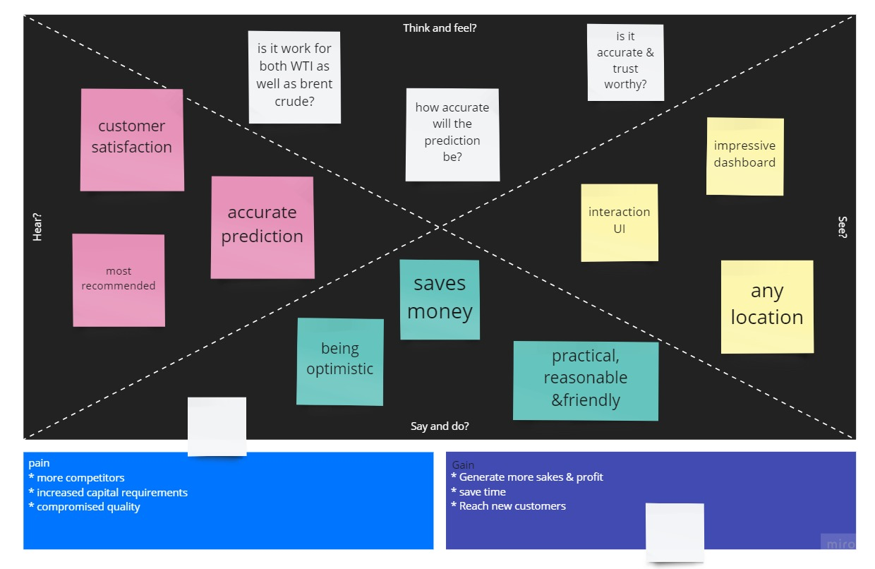

**3.2 IDEATION & BRAINSTORMING:**

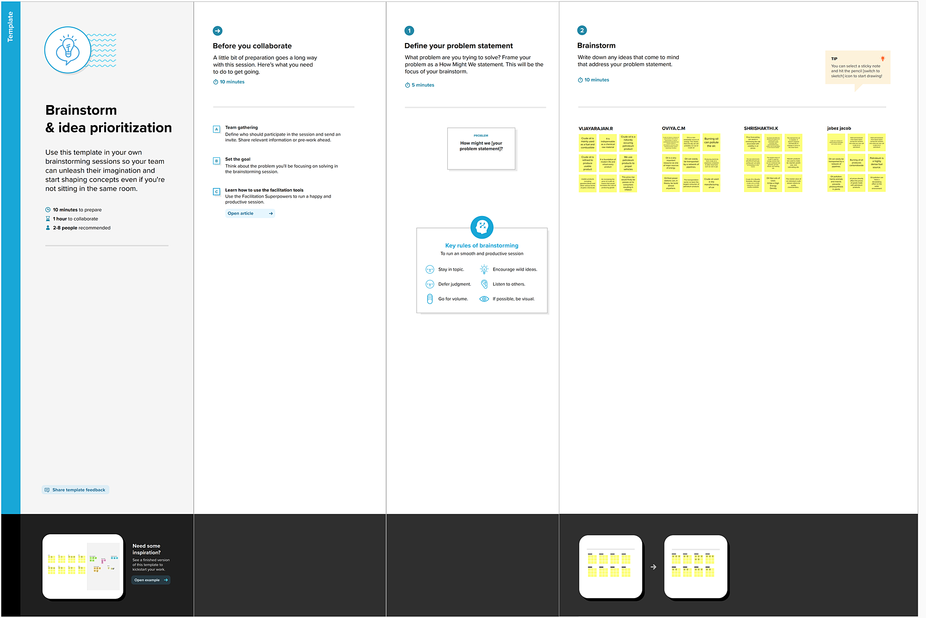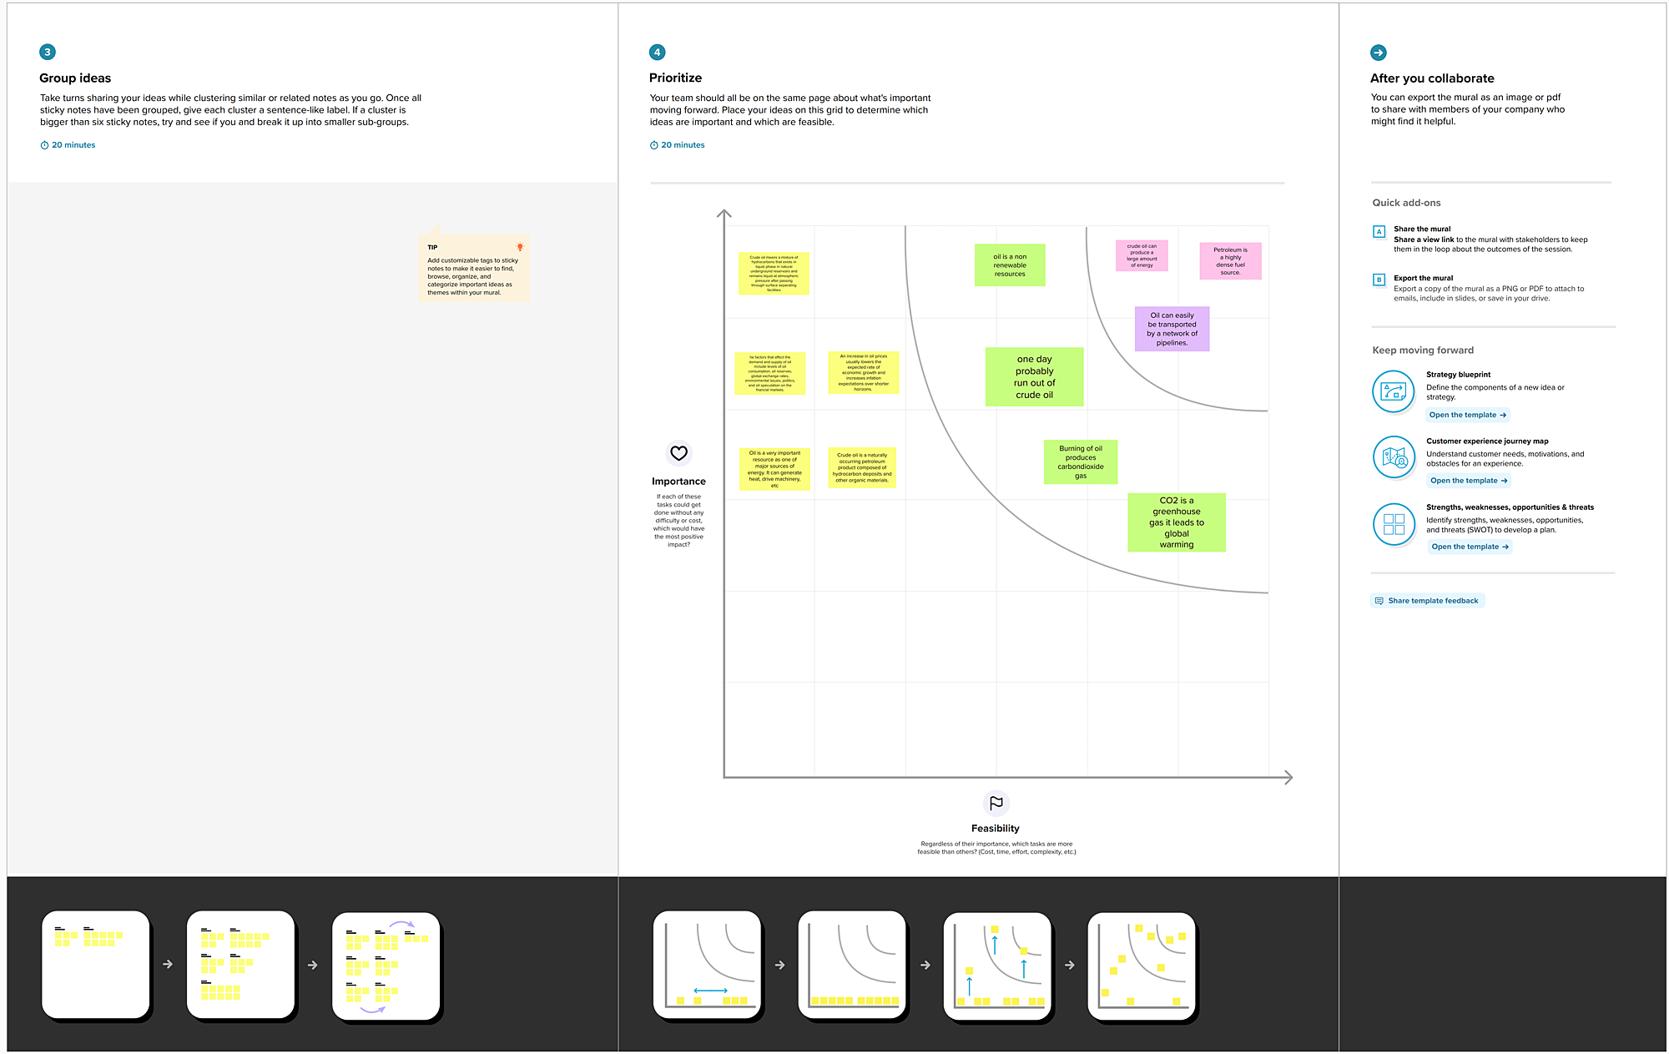

**3.4 PROBLEM SOLUTION FIT:**

|  |  |  |
| --- | --- | --- |
| **S.No.** | **Parameter** | **Description** |
|  | Problem Statement (Problem to be solved) | * To predict the crude oil price * To compare it with previous year records and analyze. |
|  | Idea / Solution description | * Prediction is done at a faster rate. * Accuracy of prediction. |
|  | Novelty / Uniqueness | * it provides robust and trusted support. * Maintaining database which contains details of the crude oil price. |
|  | Social Impact / Customer Satisfaction | * Helps us to buy crude oil at the proper time. * Very helpful in making decisions faster. * Can be used 24x7. |
|  | Business Model (Revenue Model) | * This can be implemented as an essential price detection method in every country. * Accurate detection and analysis can encourage the increase in financial benefit. |
|  | Scalability of the Solution | * Accurate predictions and extensive use. * Availability. |

**4. REQUIREMENT ANALYSIS:**

**4.1. Functional requirement:**

|  |  |  |
| --- | --- | --- |
| **FR No.** | **Functional Requirement (Epic)** | **Sub Requirement (Story/ Sub-Task)** |
| FR-1 | User Registration | Registration through Mobile number Registration throughGmail |
| FR-2 | User Confirmation | Confirmation viaEmail  Confirmation via OTP |
| FR-3 | Login | User can login through registered email ID/Mobilenumber |
| FR-4 | HOME PAGE | About the project |
| FR-5 | Predicition | Build the model |

**4.2. Non-Functional requirements:**

|  |  |  |
| --- | --- | --- |
| **FR No.** | **Non-Functional Requirement** | **Description** |
| NFR-1 | **Usability** | UI is user-friendly .we represent the data in charts whichuses clear understanding of price activity |
| NFR-2 | **Security** | We follow certain security protocols like usinguser  credentials , OTP verification |
| NFR-3 | **Reliability** | The Datawhich represented in web app is so accurate and predicting the rightdata |
| NFR-4 | **Performance** | The performance in thisproject is determined  through “howaccurately you can predict the price ofthe crude oil “ |
| NFR-5 | **Availability** | The web app is available to all devices(Android , Mac  , windows etc.,) |

**5. PROJECT DESIGN:**

**5.1. Data Flow Diagrams:**

A Data Flow Diagram (DFD) is a traditional visual representation of the information flows within a system. A neat and clear DFD can depict the right amount of the system requirement graphically. It shows how data enters and leavesthe system, what changes the information, and where data is stored.

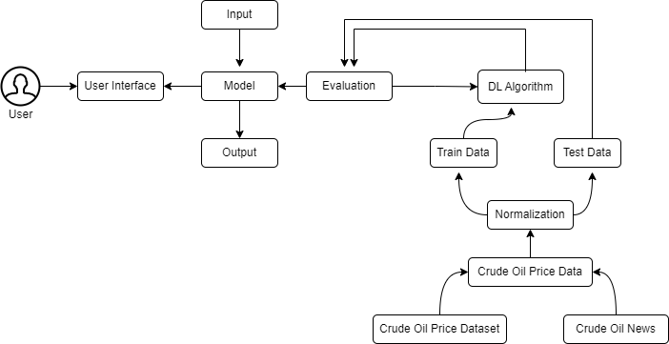

**5.2. Solution & Technical Architecture:**

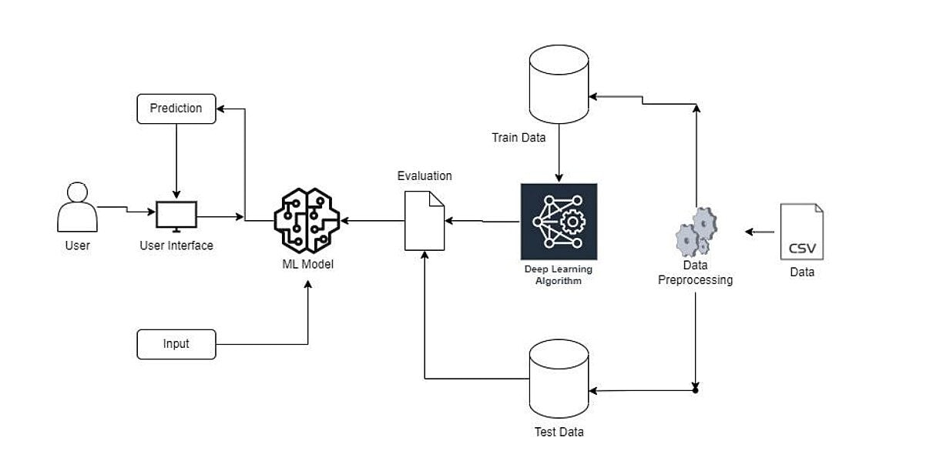

**5.3. USER STORIES:**

|  |  |  |  |  |  |  |
| --- | --- | --- | --- | --- | --- | --- |
| **User Type** | **Functional Requirement**  **(Epic)** | **User Story Number** | **User Story / Task** | **Acceptance criteria** | **Priority** | **Release** |
| Customer (Mobileuser) | Registration | USN-1 | As a user,I can register for the application  by entering my email,password, and confirming my password. | I can access my account  / dashboard | High | Sprint-1 |
|  |  | USN-2 | As a user, I will receive confirmation email once I have registered for the application | I can receive confirmation email &  click confirm | High | Sprint-1 |
|  |  | USN-3 | As a user, I can register for the application through Facebook | I can register & access the dashboard with  Facebook Login | Low | Sprint-2 |
|  |  | USN-4 | As a user, I can register for the application through Gmail | I can register through  already existing mail account. | Medium | Sprint-1 |
|  | Login | USN-5 | As a user, I can log into the application by entering email & password | After registration, I can log invia only email &  password. | High | Sprint-1 |
|  | Dashboard | USN-6 | Display the oil price,line graph / bar graphreal time. | I can expectthe prediction in various  formats. | Low | Sprint-3 |
| Customer (Web user) | Login | USN-7 | As the user, I can login by using Gmail or Facebook account or LinkedIn or by registering. | Existing users can easily login. | High | Sprint-2 |
| Customer Care Executive | Support | USN-8 | The Customer care service will provide solutions for any FAQ and also provide  Chat-Bot. | I can solve the problems raised. | High | Sprint-3 |

|  |  |  |  |  |  |  |
| --- | --- | --- | --- | --- | --- | --- |
| **User Type** | **Functional**  **Requirement (Epic)** | **User Story Number** | **User Story / Task** | **Acceptance criteria** | **Priority** | **Release** |
| Administrator | Access Control | USN-9 | Admin can control theaccess of users. | Access permission for Users. | High | Sprint-4 |
|  | Database | USN-10 | Admin can store the details of users. | Stores User details. | Medium | Sprint-4 |
|  | News | USN-11 | Admin will givethe recent newsof Oil  Prices. | Provide the recentoil  prices. | Medium | Sprint-4 |
|  | Notification | USN-12 | Admin will notify when the oil prices changes. | Notification by Gmail. | High | Sprint-4 |

**6. PROJECT PLANNING & SCHEDULING:**

**6.1. SPRINT PLANNING & ESTIMATION:**

|  |  |  |  |  |  |  |
| --- | --- | --- | --- | --- | --- | --- |
| **Sprint** | **Functional Requirement(Epic)** | **User Story Number** | **User Story/Task** | **Story Points** | **Priority** | **Team Members** |
| Sprint-1 | Data Collection | USN-1 | Download Crude Oil Price Dataset | 2 | Medium | Oviya C M |
| Sprint-1 | Data Preprocessing | USN-2 | Importing The Dataset into Workspace | 1 | Low | Jabez Jacob J |
| Sprint-1 |  | USN-3 | Handling Missing Data | 3 | Medium | Vijayarajan R |
| Sprint-1 |  | USN-4 | Feature Scaling | 3 | Low | Shrishakthi K |
| Sprint-1 |  | USN-5 | Data Visualization | 3 | Medium | Vijayarajan R |
| Sprint-1 |  | USN-6 | Splitting Data into Train and Test | 4 | High | Oviya C M |
| Sprint-1 |  | USN-7 | Creating A Dataset with Sliding Windows | 4 | High | Vijayarajan R |
| Sprint-2 | ModelBuilding | USN-8 | Importing The Model Building Libraries | 1 | Medium | Shrishakthi K |
| Sprint-2 |  | USN-9 | Initializing The Model | 1 | Medium | Jabez Jacob J |
| Sprint-2 |  | USN-10 | Adding LSTM Layers | 2 | High | Vijayarajan R |
| Sprint-2 |  | USN-11 | Adding Output Layers | 3 | Medium | Oviya C M |
| Sprint-2 |  | USN-12 | Configure The Learning Process | 4 | High | Shrishakthi K |

|  |  |  |  |  |  |  |
| --- | --- | --- | --- | --- | --- | --- |
| **Sprint** | **Functional Requirement(Epic)** | **User Story Number** | **User Story/Task** | **Story Points** | **Priority** | **Team Members** |
| Sprint-2 |  | USN-13 | Train The Model | 2 | Medium | Vijayarajan R |
| Sprint-2 |  | USN-14 | Model Evaluation | 1 | Medium | Oviay C M |
| Sprint-2 |  | USN-15 | Save The Model | 2 | Medium | Jabez Jacob J |
| Sprint-2 |  | USN-16 | Test The Model | 3 | High | Shrishakthi K |
| Sprint-3 | ApplicationBuilding | USN-17 | Create An HTML File | 4 | Medium | Jabez Jacob J |
| Sprint-3 |  | USN-18 | Build Python Code | 4 | High | Vijayarajan R |
| Sprint-3 |  | USN-19 | Run The App in Local Browser | 4 | Medium | Oviya C M |
| Sprint-3 |  | USN-20 | Showcasing Prediction On UI | 4 | High | Shrishakthi K |
| Sprint-4 | TrainTheModelOnIBM | USN-21 | Register For IBM Cloud | 4 | Medium | Vijayarajan R |
| Sprint-4 |  | USN-22 | Train The ML Model On IBM | 8 | High | Vijayarajan R |
| Sprint-4 |  | USN-23 | Integrate Flask with Scoring End Point | 8 | High | Vijayarajan R |

**6.2. SPRINT DELIVERY SCHEDULE:**

|  |  |  |  |  |  |  |
| --- | --- | --- | --- | --- | --- | --- |
| **Sprint** | **Total Story Points** | **Duration** | **Sprint Start Date** | **Sprint End Date(Planned)** | **Story Points Completed (as on Planned End Date)** | **Sprint Release Date(Actual)** |
| Sprint-1 | 20 | 6Days | 24Oct2022 | 29Oct2022 | 20 | 29Oct2022 |
| Sprint-2 | 20 | 6Days | 31Oct2022 | 05Nov2022 | 20 | 03Nov2022 |
| Sprint-3 | 20 | 6Days | 07Nov2022 | 12Nov2022 | 20 | 10Nov2022 |
| Sprint-4 | 20 | 6Days | 14Nov2022 | 19Nov2022 | 20 | 17Nov2022 |

**6.3. REPORTS FROM JIRA:**

**Velocity:**

Imagine we have a 10-daysprint duration ,and the velocity of the team is 20(points per sprint). Let’s calculate the team’s average velocity(AV)per iteration unit(story points per day)

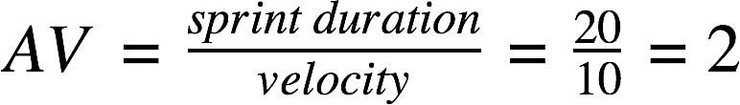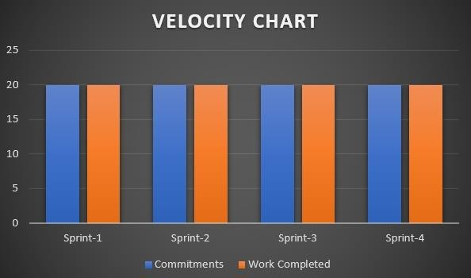

# Burn downChart:

A burn down chart is a graphical representation of work left to do versus time. It is often used in agile [software development](https://www.visual-paradigm.com/scrum/what-is-agile-software-development/) methodologies such as [Scrum](https://www.visual-paradigm.com/scrum/scrum-in-3-minutes/). However, burn down charts can be applied to any project containing measurable progress overtime.

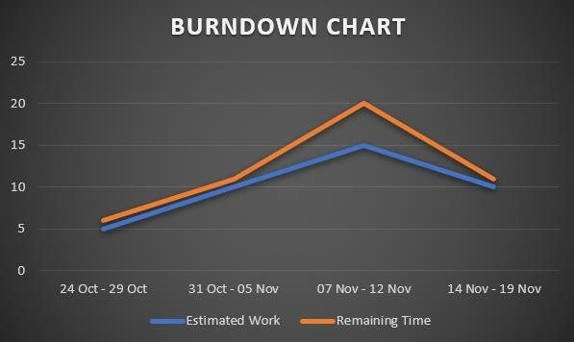

**7. CODING AND SOLUTIONING:**

This project is about oil price prediction using LSTM and RNN . so first collect the data set. the dataset can be train and test with python and the dataset with build the model . that model can be used for the final result of the project.

**7.1. CREATING MODEL:**

The model will be creating a model for the predicit the next day value

**Import the model building Libraries**

import pandas as pd

import numpy as np

import matplotlib.pyplot as plt

**loading dataset**

data = pd.read_excel(r"E:\Final Deliverables\Crude Oil Price Prediction\Dataset\Crude Oil Prices Daily.xlsx")

data

data.isnull().sum()

data.dropna(axis=0,inplace=True)

data.isnull().sum()

data_oil=data.reset_index()['Closing Value']

data_oil

from sklearn.preprocessing import MinMaxScaler

scaler=MinMaxScaler(feature_range=(0,1))

data_oil=scaler.fit_transform(np.array(data_oil).reshape(-1,1))

data_oil

plt.plot(data_oil)

training_size=int(len(data_oil)*0.65)

test_size=len(data_oil)-training_size

train_data,test_data=data_oil[0:training_size,:],data_oil[training_size:len(data_oil),:1]

training_size,test_size

train_data.shape

def create_dataset(dataset,time_step=1):

dataX,dataY=[],[]

for i in range(len(dataset)-time_step-1):

a=dataset[i:(i+time_step),0]

dataX.append(a)

dataY.append(dataset[i+time_step,0])

return np.array(dataX),np.array(dataY)

time_step=10

x_train,y_train=create_dataset(train_data,time_step)

x_test,y_test=create_dataset(test_data,time_step)

print(x_train.shape),print(y_train.shape)

print(x_test.shape),print(y_test.shape)

x_train

x_train=x_train.reshape(x_train.shape[0],x_train.shape[1],1)

x_test=x_test.reshape(x_test.shape[0],x_test.shape[1],1)

**Adding LSTM Layers**

from tensorflow.keras.models import Sequential

from tensorflow.keras.layers import Dense

from tensorflow.keras.layers import LSTM

model=Sequential()

model.add(LSTM(50,return_sequences=True,input_shape=(10,1)))

model.add(LSTM(50,return_sequences=True))

model.add(LSTM(50))

model.add(Dense(1))

model.summary()

**Configure the Learning Process**

model.compile(loss='mean_squared_error',optimizer='adam')

**Train The Model**

model.fit(x_train,y_train,validation_data=(x_test,y_test),epochs=3,batch_size=64,verbose=1)

**Model Evaluation**

##Transformback to original form

train_predict=scaler.inverse_transform(train_data)

test_predict=scaler.inverse_transform(test_data)

### Calculate RMSE performance metrics

import math

from sklearn.metrics import mean_squared_error

math.sqrt(mean_squared_error(train_data,train_predict))

**Save the Model**

from tensorflow.keras.models import load_model

model.save("crude_oil.hs")

**Test The Model**

### Plotting

look_back=10

trainpredictPlot = np.empty_like(data_oil)

trainpredictPlot[:, :]= np.nan

trainpredictPlot[look_back:len(train_predict)+look_back, :] = train_predict

# shift test predictions for plotting

testPredictplot = np.empty_like(data_oil)

testPredictplot[:,: ] = np.nan

testPredictplot[look_back:len(test_predict)+look_back, :] = test_predict

# plot baseline and predictions

plt.plot(scaler.inverse_transform(data_oil))

plt.show()

len(test_data)

x_input=test_data[2866:].reshape(1,-1)

x_input.shape

temp_input=list(x_input)

temp_input=temp_input[0].tolist()

temp_input

lst_output=[]

n_steps=10

i=0

while(i<10):

if(len(temp_input)>10):

#print(temp_input)

x_input=np.array(temp_input[1:])

print("{} day input {}".format(i,x_input))

x_input=x_input.reshape(1,-1)

x_input = x_input.reshape((1, n_steps, 1)) #print(x_input)

yhat = model.predict(x_input, verbose=0)

print("{} day output {}".format(i,yhat))

temp_input.extend(yhat[0].tolist())

temp_input=temp_input[1:] #print(temp_input)

lst_output.extend(yhat.tolist())

i=i+1

else:

x_input = x_input.reshape((1, n_steps,1))

yhat = model.predict(x_input, verbose=0)

print(yhat[0])

temp_input.extend(yhat[0].tolist())

print(len(temp_input))

lst_output.extend(yhat.tolist())

i=i+1

day_new=np.arange(1,11)

day_pred=np.arange(11,21)

len(data_oil)

plt.plot(day_new, scaler.inverse_transform(data_oil[8206:]))

plt.plot(day_pred, scaler.inverse_transform(lst_output))

df3=data_oil.tolist()

df3.extend(lst_output)

plt.plot(df3[8100:])

df3=scaler.inverse_transform(df3).tolist()

plt.plot(scaler.inverse_transform(data_oil))

**8. TESTING**

**8.1. Test Cases:**

A test case is nothing but a series of step executed on a product, using a predefined set of input data, expected to produce a pre-defined set of outputs, in a given environment. It describes “how” to implement those test cases. Test case specifications are useful as it enlists the specification details of the items. The purpose of testing is to discover errors . Testing is the process of trying to discover every conceivable fault or weakness in a work product . It provide a way to check the functionality of component , sub assemblies , assemblies and/or a finished product. It is the process of exercising software with the intent of ensuring that the software system meets its requirement and user expectation and does not fail in an unacceptable manner. There are various types of testing. Each test type addressing a specific testing requirement. The testing report are submitted

# Defect Analysis

This report showsthe number of resolved or closed bugs at each severity level, and how they were resolved

|  |  |  |  |  |  |
| --- | --- | --- | --- | --- | --- |
| **Resolution** | **Severity 1** | **Severity 2** | **Severity 3** | **Severity 4** | **Subtotal** |
| By Design | 10 | 4 | 2 | 3 | 20 |
| Duplicate | 1 | 0 | 3 | 0 | 4 |
| External | 2 | 3 | 0 | 1 | 6 |
| Fixed | 11 | 2 | 4 | 20 | 37 |
| Not Reproduced | 0 | 0 | 1 | 0 | 1 |
| Skipped | 0 | 0 | 1 | 1 | 2 |
| Won't Fix | 0 | 5 | 2 | 1 | 8 |
| Totals | 24 | 14 | 13 | 26 | 77 |

**Test Case Analysis**

This report shows the numberof test cases that have passed, failed,and untested

|  |  |  |  |  |
| --- | --- | --- | --- | --- |
| **Section** | **Total Cases** | **Not Tested** | **Fail** | **Pass** |
| Home page | 7 | 0 | 0 | 7 |
| Prediction page | 51 | 0 | 0 | 51 |
| Model file | 2 | 0 | 0 | 2 |
| Retrive the data form model | 3 | 0 | 0 | 3 |
| Exception Reporting | 9 | 0 | 0 | 9 |
| Final ReportOutput | 4 | 0 | 0 | 4 |
| Version Control | 2 | 0 | 0 | 2 |

**8.2. Performance Test:**

|  |  |  |  |
| --- | --- | --- | --- |
| **S.No.** | **Parameter** | **Values** | **Screenshot** |
|  | Model Summary | **-** |  |
|  | Accuracy | Training Accuracy -    Validation Accuracy - 29.347830443269938 |  |

**9. RESULTS:**

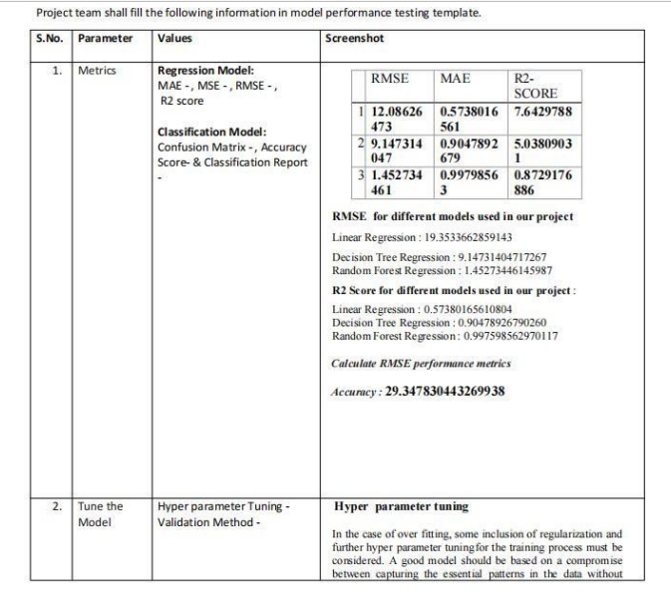

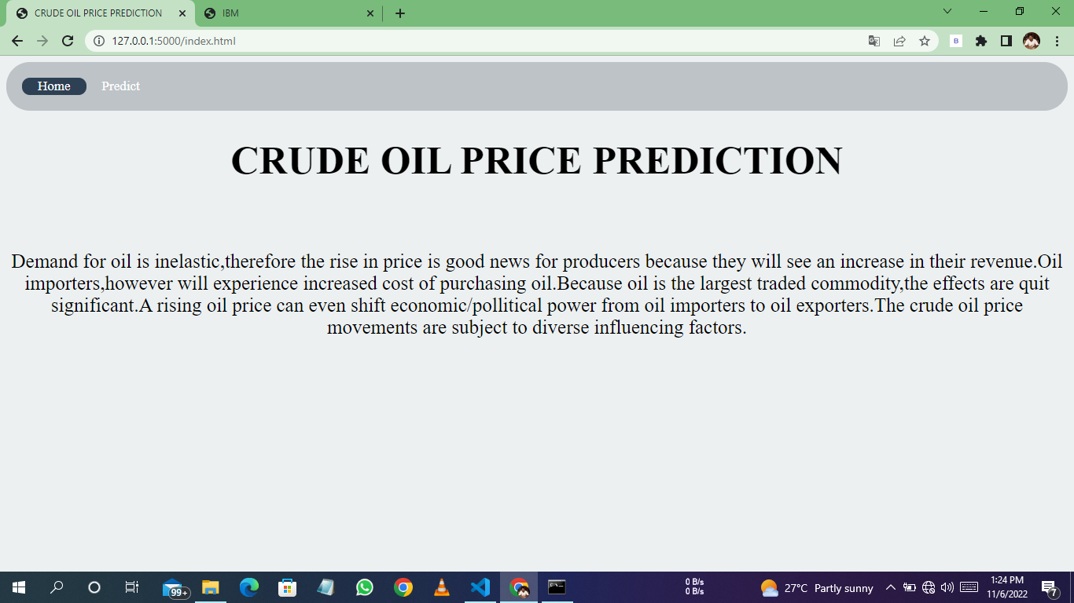

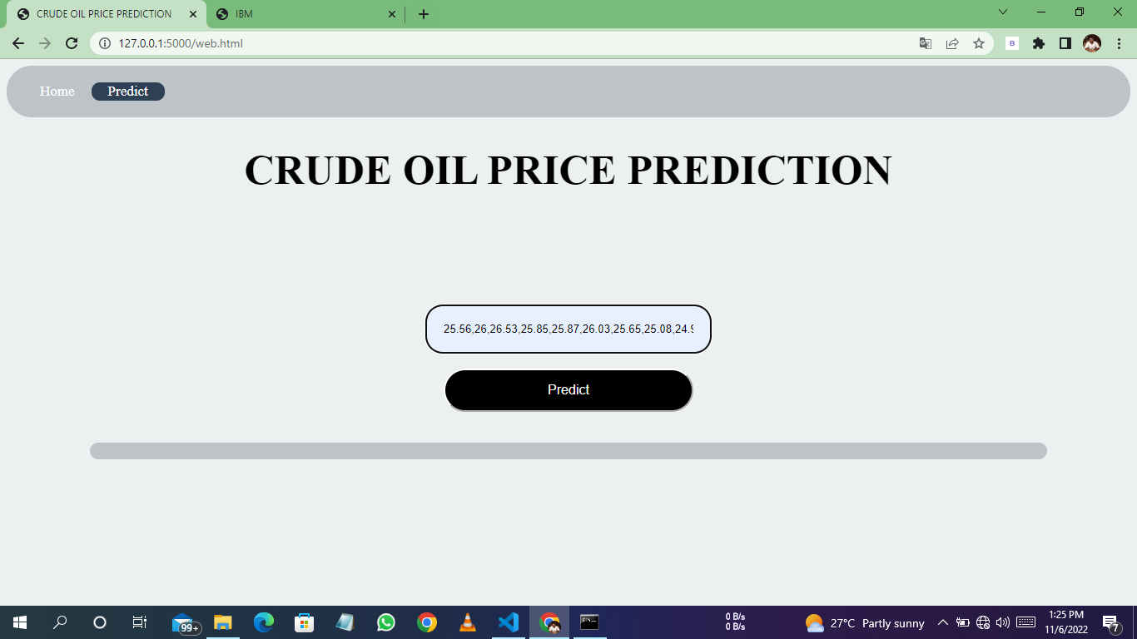

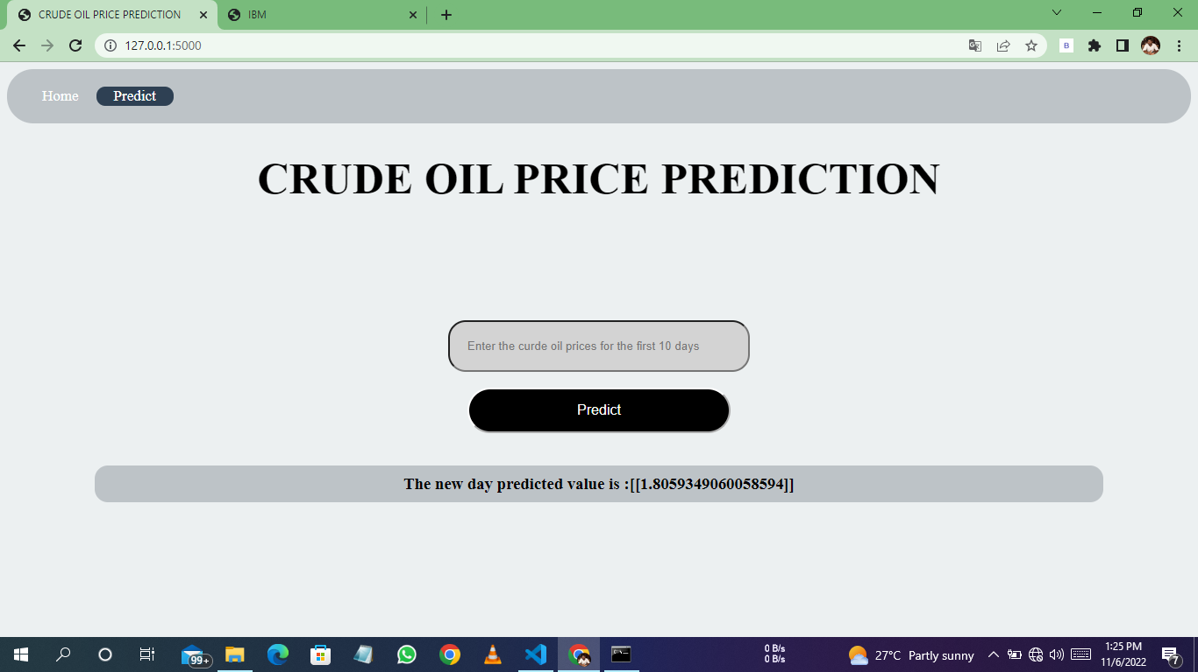

**10.ADVANTAGES:**

1. The advantage of this model are high performance and accuracy rate.

2. It is very flexible and high rates of success are achieved

3. The application when implemented using random forests has more accuracy rate when compare to other algorithm. In this system, we achieve around 98%.

**11. CONCLUTION:**

The main purpose of this paper is to develop a time series collection of regular observations on oil price datasets. Used to predict future value based on historical data. Non- linear trends are fitted using annual, weekly, and daily data. This white paper integrates machine learning models such as FB Prophet a to analyze, classify, and predict time series data.Historical data is presented using variables analyzed and calculated during the algorithm execution module, and each algorithm makes a series of oil price predictions using this setof values.

**12. FUTURE SCOPE:**

The project's future potential is enormous. The project can be implemented with the real-time functionalities that are necessary. Because it is quite versatile in terms of expansion, the project can be upgraded in the near future as and when the need arises. The complete prediction value can be increased in a much better, accurate, and error-free mannerwith the proposed approach. The project can be enhanced withreal time data

**13. APPENDIX:**

PYTHON Python is a computer programming language often used to build websites and software, automate tasks, and conduct data analysis. Python is a general purpose language, meaning it can be used to create a variety of different programs and isn't specialized for any specific problems.

**SOURCE CODE:**

**app.py**

import numpy as np

from flask import Flask,render_template,request

from tensorflow.keras.models import load_model

app=Flask(__name__)

model = load_model('E:\Final Deliverables\Crude Oil Price Prediction\Flask\crude_oil.hs')

@app.route('/index.html')

def home():

return render_template("index.html")

@app.route('/web.html')

def home1():

return render_template("web.html")

@app.route('/',methods = ["POST"])

def login():

x_input=str(request.form['year'])

x_input=x_input.split(',')

print(x_input)

for i in range (0, len(x_input)):

x_input[i]=float(x_input[i])

print(x_input)

x_input=np.array(x_input).reshape(1,-1)

temp_input=list(x_input)

temp_input=temp_input[0].tolist()

lst_output=[]

n_steps=10

i=0

while(i<1):

if (len(temp_input)>10):

x_input=np.array(temp_input[1:])

print("{}day input {}".format(i,x_input))

x_input=x_input.reshape(1,-1)

x_input=x_input.reshape((1,n_steps,1))

yhat=model.predict(x_input,verbose=0)

print("{}day output {}".format(i,yhat))

temp_input.extend(yhat[0].tolist())

temp_input=temp_input[1:]

lst_output.extend(yhat.tolist())

i=i+1

else:

x_input=x_input.reshape((1,n_steps,1))

yhat=model.predict(x_input,verbose=0)

print(yhat[0])

temp_input.extend(yhat[0].tolist())

print(len(temp_input))

lst_output.extend(yhat.tolist())

i=i+1

print(lst_output)

return render_template("web.html",showcase = 'The new day predicted value is :'+str(lst_output))

if __name__ == '__main__':

app.run(debug = True,port = 5000)

**home.html**

<!DOCTYPE html>

<html>

<head>

<title>CRUDE OIL PRICE PREDICTION</title>

<meta charset="UTF-8">

<meta name="viewport" content="width=device-width, initial-scale=1">

<link rel="stylesheet" type="text/css" href="{{ url_for('static', filename='css/style.css') }}">

<link rel="stylesheet" href="https://cdnjs.cloudflare.com/ajax/libs/font-awesome/4.7.0/css/font-awesome.min.css">

</head>

<body>

<div class="header">

<div class="topnav">

<a class="active" href="index.html">Home</a>

<a href="web.html">Predict</a>

</div>

</div>

<div class="intro" >

<h1>CRUDE OIL PRICE PREDICTION</h1>

<br>

<p> Demand for oil is inelastic,therefore the rise in price is good news for producers because they will see an increase in their revenue.Oil importers,however will experience increased cost of purchasing oil.Because oil is the largest traded commodity,the effects are quit significant.A rising oil price can even shift economic/pollitical power from oil importers to oil exporters.The crude oil price movements are subject to diverse influencing factors.

</p>

</div>

</body>

</html>

**web.html**

<!DOCTYPE html>

<html>

<head>

<title>CRUDE OIL PRICE PREDICTION</title>

<meta charset="UTF-8">

<meta name="viewport" content="width=device-width, initial-scale=1">

<link rel="stylesheet" type="text/css" href="{{ url_for('static', filename='css/style.css') }}">

<link rel="stylesheet" href="https://cdnjs.cloudflare.com/ajax/libs/font-awesome/4.7.0/css/font-awesome.min.css">

</head>

<body>

<div class="header">

<div class="topnav">

<a href="index.html">Home</a>

<a class="active" href="web.html">Predict</a>

</div>

</div>

<div class="intro" >

<h1>CRUDE OIL PRICE PREDICTION</h1>

</div>

<div class="inputform">

<form action="{{ url_for('login')}}" method="post">

<input type="text" id="year" name="year" class="input" placeholder="Enter the curde oil prices for the first 10 days">

<br><br>

<input type="submit" value="Predict" onclick="login()" class="btin">

<br><br>

<h3>{{showcase}}</h3>

</form>

</div>

</body>

</html>

**style.css**

body {

background-color:#ECF0F1;

font-family:Nyala;

margin: 10;

border: 10px;

width: auto;

}

.header {

padding: 20px;

text-align: center;

background:#BDC3C7 ;

color:white;

border-radius: 30px ;

}

.topnav{

overflow: hidden;

}

.topnav a{

float:left;

color: white;

text-align:right;

padding: 1px 20px;

text-decoration:none;

border-radius: 5pxs;

font-size: 17px;

}

.topnav a:hover{

background-color:#BDC3C7;

border-radius: 10px;

color:black;

}

.topnav a.active{

border-radius: 10px;

background-color:#2E4053 ;

color: white;

}

.intro{

font-size: 25px;

text-align: center;

}

.inputform{

padding: 100px;

align-content: center;

}

.input{

padding: 20px;

border-radius: 20px;

width: 300px;

background-color: lightgrey;

}

.btin{

background-color: black; /* Green */

border-color: white;

box-shadow: #BDC3C7;

color: white;

padding: 15px 32px;

text-align: center;

text-decoration: none;

display: inline-block;

font-size: 16px;

width: 300px;

color: white;

border-radius: 30px;

}

.inputform{

text-align: center;

}

h3 {

background-color:#BDC3C7 ;

width: auto;

border-radius: 15px;

border-color: black;

padding: 10px;

}

**SCREEN SHOT:**



**GITHUB & PROJECT DEMO LINK:**

**<https://github.com/IBM-EPBL/IBM-Project-54351-1661853701>**